**Semester Project Phase 3: Project Proposal**

**Project: Word of the Day Educational Tool**

Uday Singh

Department of Computer Science, University of Idaho

CS210: Programming Languages

Dr. Travis DeVault

March 16, 2025

**Programming Language:** C#

**Project purpose and functionality:**

The **Word of the Day Educational Tool** is a C# software application designed to enhance vocabulary learning through daily exposure to new words. This application will display a new word each day, providing its definition, pronunciation, usage examples, and related synonyms. Users can also engage in quizzes to reinforce their learning and track their progress over time.

The project aims to support personal language development for students, language enthusiasts, and anyone looking to expand their vocabulary. This tool will serve as an engaging educational resource that demonstrates various programming concepts, including file handling, user interfaces, data structures, and algorithm implementation.

**Reason for choosing this project:**

This project aligns with my passion for learning and sharing knowledge. By developing an educational tool that teaches words of the day, I aim to create a practical, user-friendly application that helps users improve their vocabulary and communication skills. Additionally, this project offers a valuable opportunity to showcase my programming abilities and deepen my understanding of C# application development, particularly in areas such as GUI design and data processing.

**Core features:**

1. **Word of the Day Display:**

* Automatically displays a new word each day with its definition, pronunciation, example sentences, and related synonyms.
* Option to view past words and revisit their details.

1. **Quiz Mode:**

* Users can take quizzes based on recently learned words.
* Multiple-choice and fill-in-the-blank questions to reinforce vocabulary learning.
* Immediate feedback on quiz results.

1. **Progress Tracking:**

* System to track user progress, including quiz scores and words learned.
* Visual representation of learning progress (e.g., percentage of words mastered).

1. **Favorite Words List:**

* Users can save words they find interesting or challenging to a personal favorites list.
* Option to review and quiz themselves on favorite words.

1. **Search and Browse Functionality:**

* Ability to search for specific words or browse through the word archive.

1. **User Interface (UI):**

* Intuitive, user-friendly interface created using Windows Forms or WPF.
* Easy navigation between Word of the Day, Quiz, Favorites, and Search functionalities.

1. **Data Storage:**

* Word data stored in a local JSON or XML file, ensuring easy addition of new words.
* Persistent user data storage for tracking progress and storing favorite words.

1. **Future Enhancements (Optional):**

* Adding audio pronunciation.
* Push notifications to remind users of the Word of the Day.
* Integration with online word databases to expand the word list dynamically.

**Software design plan:**

1. **Architecture:**

* **Presentation Layer:** User interface handling display and interaction.
* **Logic Layer:** Manages word generation, quizzes, progress tracking, and data storage.
* **Data Layer:** Handles reading and writing word data and user progress to files.

1. **Data Flow:**

* User interacts with the interface → Application retrieves word data → Displays Word of the Day → Tracks user progress through quizzes → Saves progress to file.

1. **Tools & Technologies:**

* C# (Language)
* Visual Studio (IDE)
* Windows Forms or WPF (For GUI)
* JSON or XML (For data storage)

**Class Diagram:**

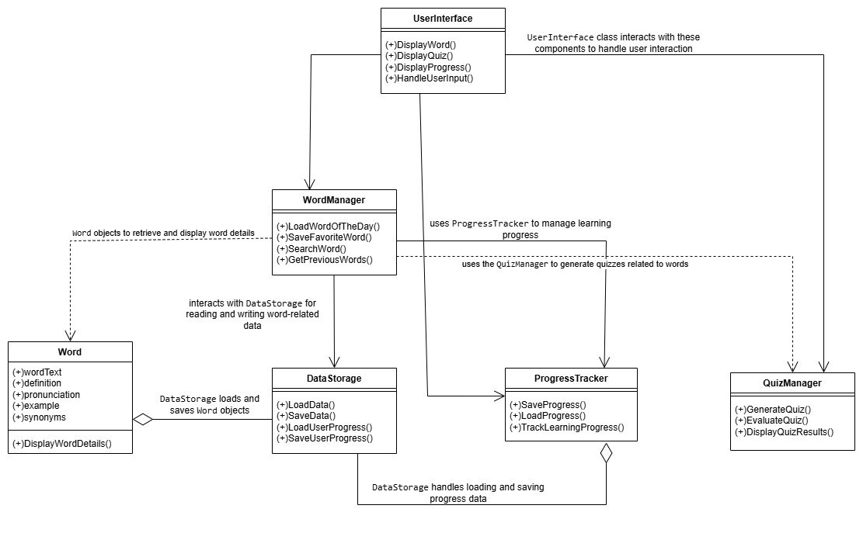

**Data Flow Diagram (Diagram 0):**

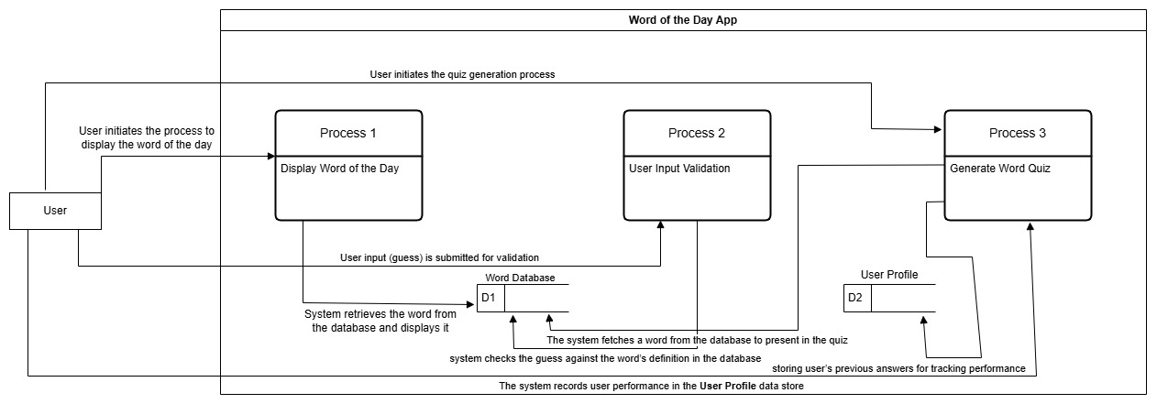

**Pseudocode:**

**Pseudocode 1:** Display word of the day

Function DisplayWordOfTheDay()

// Fetch the word of the day from the Word Database

wordOfTheDay = FetchFromDatabase("WordOfTheDay")

// Display the word and its definition

Display(wordOfTheDay.name)

Display(wordOfTheDay.definition)

End Function

**Pseudocode 2:** Validate User Input

Function ValidateUserInput(userInput)

// Fetch the correct definition from the database

correctDefinition = FetchFromDatabase(userInput.word)

// Check if the user’s input matches the correct definition

If userInput.definition == correctDefinition Then

Return True

Else

Return False

End If

End Function

**Pseudocode 3:** Generate Word Quiz

Function GenerateWordQuiz()

// Fetch a random word from the Word Database

word = FetchRandomFromDatabase("Words")

// Fetch the correct definition

correctDefinition = FetchFromDatabase(word)

// Create a set of multiple-choice options (including the correct definition)

options = GenerateOptions(correctDefinition)

// Display the word and options to the user

Display(word)

DisplayOptions(options)

// Get the user’s answer and validate

userAnswer = GetUserInput()

If ValidateUserInput(userAnswer) Then

Display("Correct!")

Else

Display("Incorrect!")

End If

End Function

**Timeline and project scope:**

The project will be completed over the course of **4 weeks** with the following milestones:

* **Week 1:** Planning and designing the user interface; Setting up the project structure.
* **Week 2:** Implementing core features (Word Display, Data Storage, UI Integration).
* **Week 3:** Adding Quiz Mode, Progress Tracking, and Favorite Words functionality.
* **Week 4:** Testing, debugging, documentation, and final polishing of the application.

**Testing plan:**

Testing will include:

* **Unit Testing:** Ensuring individual functions (e.g., word generation, quizzes) work as intended.
* **Integration Testing:** Confirming proper interaction between UI components and logic.
* **User Testing:** Gathering feedback on usability and making improvements.

**Conclusion:**

The **Word of the Day Educational Tool** project will demonstrate my skills in software design, user interface creation, file handling, and algorithm implementation using C#. This project will also serve as a valuable addition to my programming portfolio, showcasing my ability to build a useful educational application.

**References:**

**GitHub repository for this project:**

<https://github.com/Udays0694/CS210_Semester_Project-SP25-/blob/main/Semester%20Project%20Phase%203%3A%20Project%20Proposal>